Marco Rodriguez Gomez
04/30/2026
Module 8.2 Assignment: JSON Practice

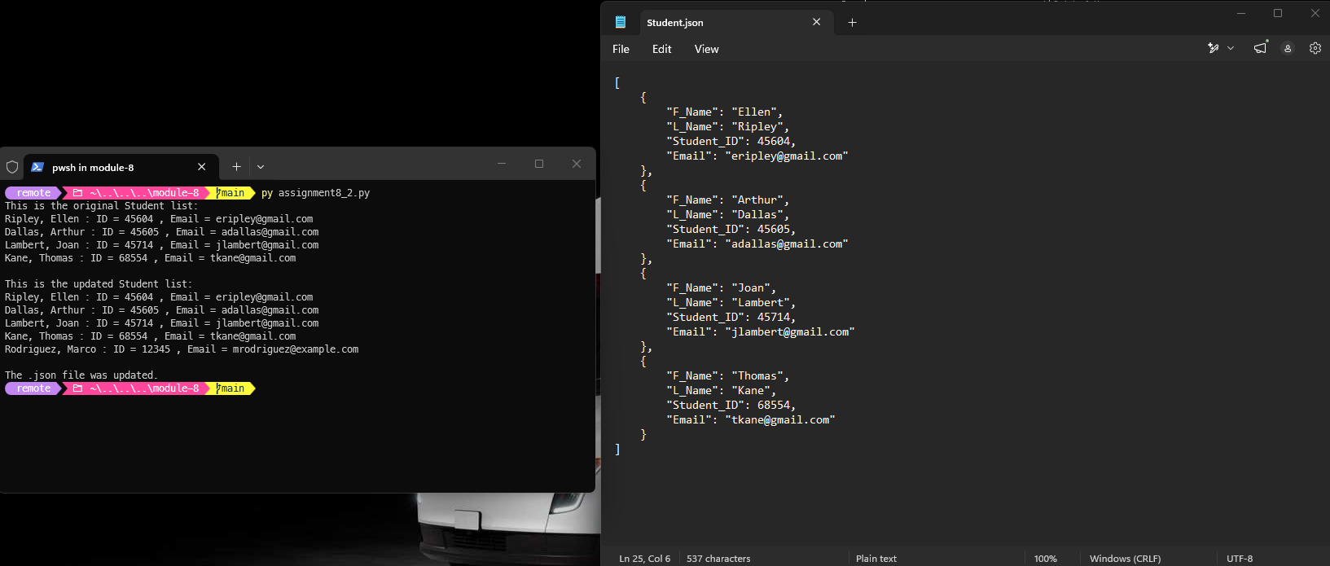

I don’t know why my PC don’t show the pop up notification but when I click on notepad it automatically update with the new file
